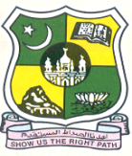

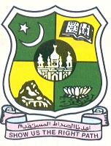
JAMAL MOHAMED COLLEGE (Autonomous)

Accredited (3rd Cycle) with ‘A’ Grade by NAAC

(Affiliated to Bharathidasan University)

Since 1951 TIRUCHIRAPPALLI -620 020.

The P.G. & Research Department of History Jamal Mohamed College, takes pride in inviting you to the Valedictory Function & Special Lecture Programme of Maulana Abul Kalam Azad History Association on 10th March, 2023, Friday at 11:00 A.M. in the Commerce Gallery (Aided)

In the august presence of

Hajee M.J.Jamal Mohamed Bilal Dr. A.K.Khaja Nazeemudeen
President Secretary & Correspondent

Hajee M.J.Jamal Mohamed Dr.K. Abdus Samad Dr. K.N. Abdul Khadar Nihal
Treasurer Assistant Secretary Member & Hon. Director

Dr.S.Ismail Mohideen

Principal, Jamal Mohamed College
has kindly consented to preside over the function
Dr. FEMILA ALEXANDER
H.O.D. of History
Bishop Heber College
Tiruchirappalli

delivers a Special Lecture on
“Women Empowerment”

By

Dr.A.Mohamed Ibraheem Dr.M.Mohamed Sihabudeen
Vice Principal Additional Vice Principal

Dr.K.N. Mohamed Fazil Ms. J. Hajira Fathima

Director-Hostel Administration Director – Women Hostel
Will offer felicitations

Dr. M. MOHAMED TAJDEEN

Vice President
Your Glorious presence will be our Great Pleasure

